1. **Install nginx and run nginx on port number 81.**

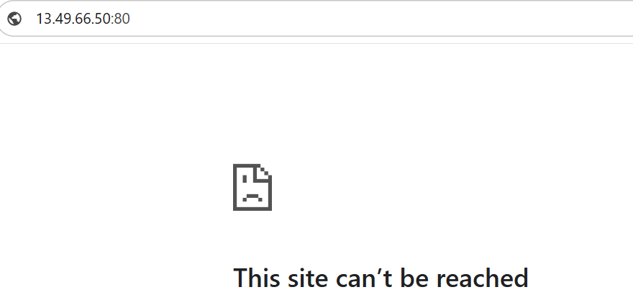

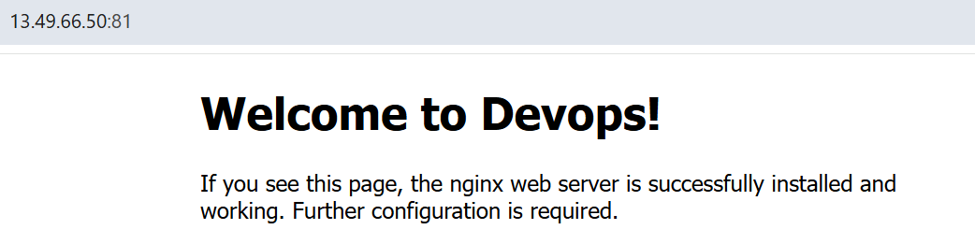

1. **Deploy a sample index.html file on nginx.**

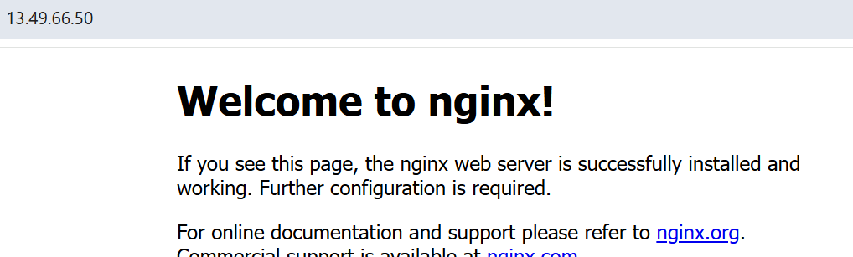

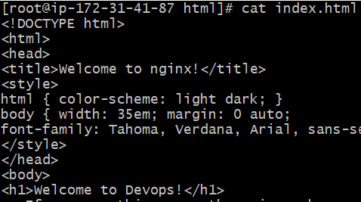

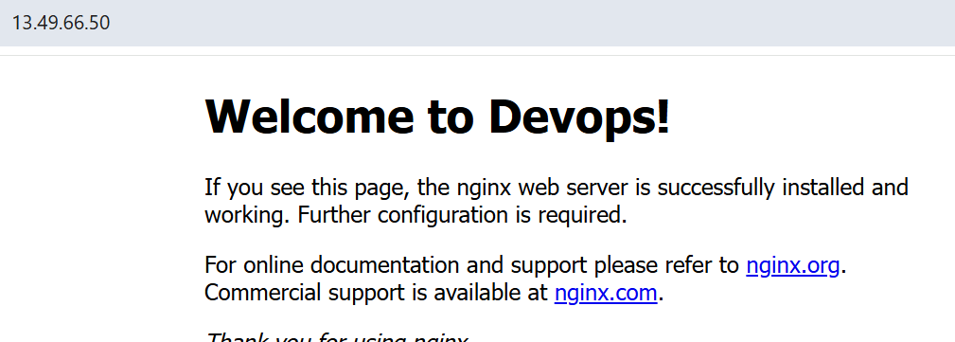

1. **Install Apache and run Apache on port number** **82**



1. **Deploy a sample index.html file on Apache.**



1. **Install Apache tomcat on port number 8082**

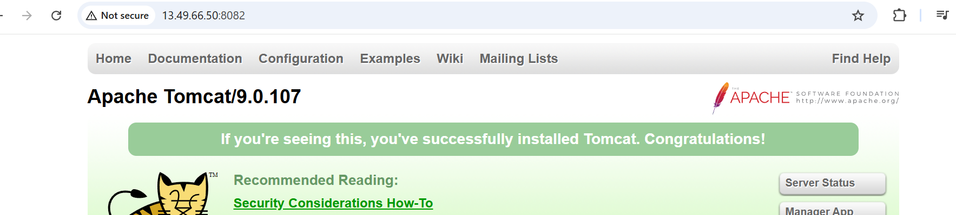

1. **Deploy a sample app on webapps**

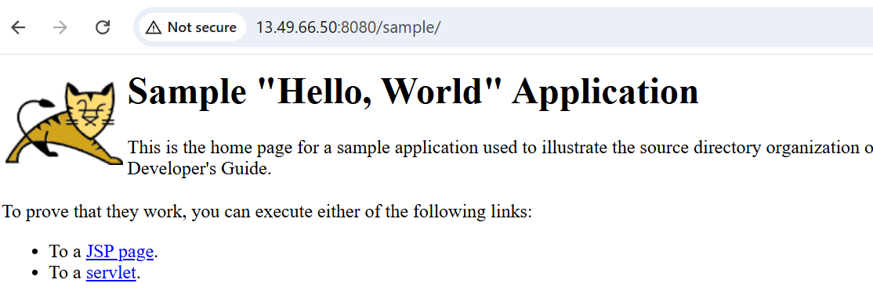

1. **Create a tomcat.service file for tomcat.**

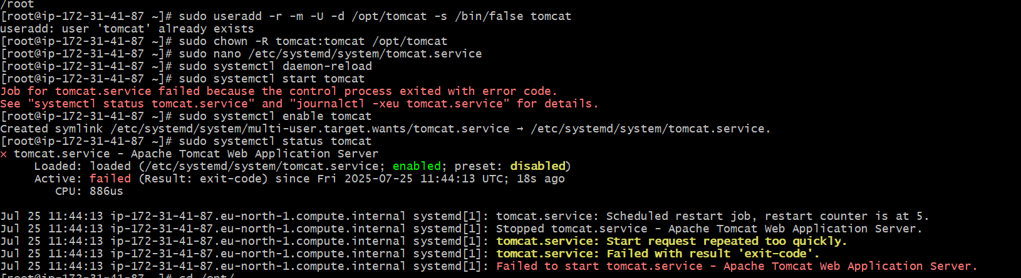

**8) Configure HA Proxy server**

